QUALIFICATION TEST PROCEDURE

FOR THE

MULTI-OIL LEVEL INDICATOR

AUTOMATION OF THE OLS TEST BENCH

ALLEN AIRCRAFT PRODUCTS, INC.

REPORT #???

PREPARED BY: Rick Ales, Consultant, R. Ales Consulting LLC

Name, Title

APPROVED BY:

Name, Title

ALLEN AIRCRAFT PRODUCTS, INC.

RAVENNA, OHI

Revision History

|  |  |  |  |
| --- | --- | --- | --- |
| **Rev** | **Notes** | **By** | **Date** |
| Draft 1 | Initial Draft | R. Ales | 2025/03/18 |
| Draft 2 | Wholesale update of test cases, first draft complete | R. Ales | 2025/04/10 |

Table Of Contents

1.0 Purpose of Test Procedure 4

1.1 Reference Documents: 4

1.2 Notation 4

2.0 Test Plan 4

2.1 Requirements Cross Reference Summaries 4

2.2 Test 5

2.3 Analysis 5

2.4 Inspection 5

2.5 Test Results Record 5

3.0 Description of Test Item 5

3.1 General Test Data Requirements 5

3.2 Criteria for Retest 6

4.0 Test Approach 6

4.1 Test Conditions 6

4.2 Measurement Tolerances 6

4.3 Test Fluids 6

4.4 Test Setups/Equipment 6

4.5 Test Procedure Revisions 6

4.6 Allen Aircraft Contacts: 7

5.0 QTP Testing 7

5.1 Functional Requirements Test Procedures 7

5.1.1 Test Initialization 7

5.1.2 Hardware Inputs: 10

5.1.3 Hardware Outputs: 13

5.1.4 HMI: 14

5.1.5 Document management 19

5.1.6 Enter parameters into XL Configuration File. 21

5.1.7 Calibration Procedure 21

5.1.8 Troubleshooting Aids 22

5.1.9 Use Case 3: Read Test Configuration -- Production Test User 23

5.1.10 Load DUT identification information 24

5.1.11 Load DUT into the test bench. 26

5.1.12 Use Case 5: Run DUT Test -- Production Test User 26

5.1.13 Use Case 5: Generate DUT Test Report -- Production Test User 35

5.2 Performance Requirements Test Procedures 37

5.2.1 Level Calibration Repeatability & Accuracy 37

5.2.2 Resistance, Calibration, Repeatability & Accuracy 38

5.2.3 Measurement Gage R & R 38

5.2.4 Stability and Drift 38

5.2.5 Tank Response and Fill Rate 38

Appendix I. Hardware Installation 38

i. DataQ Switching between LibUSB and CDC Modes 38

ii. DataQ Troubleshooting 39

Appendix II. Instrument Initialization 39

Appendix III. LabVIEW Application Installation 39

1. Purpose of Test Procedure

The purpose of the Qualification Testing Procedure is to demonstrate how the Allen Aircraft Automated Oil Level Sensor Test Bench, aka Multi-Level Oil Indicator (MLOI) shall perform within the requirements of Technical Requirements for the Multi-Level Oil Indicator Automated OLS Test Bench, Report #250129 (ReqSpec).

* 1. Reference Documents:

ACCEPTANCE TEST PROCEDURE FOR ALLEN 8005571.05, Report# 200333

* 1. Notation
* Means Informative

1. **Means Test Case traceable to a Requirement**

LV LabVIEW

VI Virtual Instrument, a top-level LabVIEW app or a sub processing block

AAP Allen Aircraft Products

QUAM AAP AS9100 Quality Manual

ATP Acceptance Test Procedure

OLS Oil Level Sensor

CIP Custom Interface PCB

DUT Device Under Test

AI Analog Input

XL MS Excel

MLOI Multi-Level Oil Indicator, designation of the automated tester described herein.

Epic 1 Single DUT automated test capability

Epic 2 MLOI capability extended to accommodate other OLS product lines.

Epic 3+ Uses the Custom Interface PCB (CIP). Also, the MLOI capability may extended to accommodate multiple sensors DUT tested simultaneously (TBD)

HW 1 Prototype phase where all items are COTS and custom configurations are achieved through breadboards or otherwise temporary connections.

HW 2 Production where custom interfaces have been designed and fit for purpose implemented, ie interface unit manufactured as a custom PCB.

<parm> Indicate the tester should supply the indicated parameter as appropriate.

1. Test Plan
   1. Requirements Cross Reference Summaries

Test cases and procedures are traceable to the requirements of ReqSpec by being numbered with the corresponding requirement number.

Upon successful execution of this QTP, the MLOI Automated OLS Test shall be deemed suitable for ATP and production testing of the approved corresponding OLS product. The initial test shall cover EPIC 1 as defined in the ReqSpec for Elevate OLS sensor (PN 8005571.05).

* 1. Test

Verification that a requirement is met is by a thorough exercising of the item. This includes actual measurement of unit performance with calculations/analysis as required under controlled and/or recorded environment and in accordance with approved test procedures.

* 1. Analysis

The requirement is substantiated by Analysis. Analysis is the processing of accumulated results and conclusions to determine whether a requirement has been verified. The analytical results may be based on original study, or derived from lower-level examination, test, demonstration, or a formal analysis.

* 1. Inspection

Inspection is a visual examination, physical manipulation, weighing and/or measurements to verify that the hardware item conforms to the design requirements and includes review of documentation controlling configuration and requirements.

* 1. Test Results Record

The test cases shall provide space to record the results of that test case, and an overall PASS/FAIL score shall be recorded. This will serve as the Test Results Record when completed and signed off by the designated stakeholders.

1. Description of Test Item

The Allen MLOI Automated OLS Test Bench is illustrated in Appendix II. The MLOI is an LabVIEW automated system intended to be a hands-free product test bench that minimizes human product evaluation by controlling the pump and data acquisition system used to precisely control the test tank oil level to a specified Test Point and measure and record the OLS response then determine if the Device Under Test response complies to the designated product ATP specification and report a PASS/FAIL status for that product at the completion of the test.

* 1. General Test Data Requirements

One MLOI Automated OLS test bench designed to comply with EPIC 1 of the ReqSpec, shall be evaluated. One or more designated and characterized OLS product will be used as DUT to evaluate the performance of the MLOI under test.

Data for each test shall be recorded on individual data sheets. Each sheet shall contain as a minimum the following:

1. Test Title: “QTP Results for MLOI Automated OLS Test Bench, EPIC 1”
2. Date of test
3. Test procedure paragraph reference
4. All pertinent environmental conditions
5. Type of fluid used and temperature (if applicable)
6. Name and signature of test operator(s)
7. Equipment, instruments, tolerances, and calibration
8. Input, output, and computed data

In addition, photographs of the test unit before and after testing, and of the test setup prior to testing must be taken and provided in the Test Report. Photographs shall be available for customer review prior to testing, if required.

Supporting data, such as a test log, a narrative history of the test and a data acquisition recording of the required test parameters (input and output), if applicable, per the test procedure, shall be made available for customer review.

* 1. Criteria for Retest

In the event of a test failure, the test shall be suspended and the cognizant <customer> representative shall be notified within 24 hours of the finding. The nature and amount of any redesign and retest shall be coordinated with and approved by <customer> prior to resumption of the test program.

1. Test Approach

Unless otherwise specified, the following general requirements shall apply to all Section 5 procedures.

* 1. Test Conditions

Unless otherwise specified, the tests shall be conducted at ambient temperatures between +70°F and +80°F and at local laboratory ambient pressure and humidity conditions up to 90% relative humidity. The ambient conditions at time of testing shall be provided on the test data sheet, as noted in Section 3.1.

* 1. Measurement Tolerances

The maximum allowable tolerance on test condition measurements shall be as follows:

1. Pressure: ± 2%
2. Temperature: ± 2°F
3. Flow: ± 2%

Other tolerances shall be as specified in the detailed procedure

* 1. Test Fluids

The MLOI test tank will use oil conforming to <test fuel spec (common name)>. The fluids for each test shall be recorded on all data sheets.

* 1. Test Setups/Equipment

Test setups are defined under the applicable sub-paragraphs of Section 5.1 herein. The Qualification Test Report shall include a complete equipment list identifying each specific instrument used for each test along with its corresponding range and accuracy.

Note: The setups illustrated are a guide. Equivalent instrument substitutes may be used as long as the measurement accuracy of the test parameter is not compromised.

* 1. Test Procedure Revisions

All test procedure revisions required during test – other than typographical errors that do not change the technical intent of the test - shall be approved in writing by the responsible AR at a minimum and included in the test report. These revisions include, but are not limited to, revisions where the initial stated objective of the procedure or method is not altered, and the means of achieving those stated goals are not altered.

* 1. Allen Aircraft Contacts:

The following list of Allen Aircraft personnel, unless otherwise noted, are responsible for the Design Testing and Quality verification of the product under test:

<name>, Project Design Engineer, email:

<name>, Test Engineer, email:

<name>, Director of Quality Assurance, email:

1. QTP Testing

Functional testing is based on an analysis of ReqSpec. Each Requirement of the ReqSpec shall be tested on a PASS/FAIL basis by the procedures described by test cases of Section 5.1, numbered corresponding to the functional Requirement being tested.

Performance testing includes but is not limited to activities such as Calibration and Gage R&R, which will be described in Section 5.2 and may deviate from the functional requirement numbering system.

* 1. Functional Requirements Test Procedures

The following test cases describe the test procedures to be used to verify the functional requirement and the success (PASS/FAIL) criteria. The tester should mark the check box if they concur; the test case passed if all check boxes are marked then the test should circle PASS otherwise circle FAIL.

Preform the following steps to load the LabVIEW application (LV), which applies to nearly all the test cases, to conduct the test procedures that follow.

Test Initialization

1. Install LabVIEW (LV) runtime as shown in Appendix III
2. Load the current version of the LV MLOI application as shown Test Case 1).

NOTE: At this point, much of the LV MLOI app functionality can be exercised in simulated mode.

1. Configure the system hardware as shown in Appendix I.
2. Initialize the instruments and motor controller as shown in Appendix II
3. All the functional tests should be run with the most current application loaded and running with all instruments online unless otherwise specified.
4. Verify both the LV application code and HW are version controlled.
5. Login to your favorite internet browser and navigate to <https://github.com/AllenAircraft/PWC-OLS/tree/main>. Contact AAP IT department for login information.

* On the code page, verify that the code under “Main” branch is populated and Release Notes are update.
* Under “Releases” to the right of the code block, verify the “Latest” release revision number corresponds to engineering documentation.

1. Verify the hardware drawings, including block diagram, schematic, assembly drawing and Gerber files are released.

* All hardware files are in the release folder at <Path file>

Tester __________________ Date ______________ PASS FAIL

1. The system shall have distinct modes, Test and Maintenance.

*We have yet to validate this requirement nor determined how to implement it.*

Tester __________________ Date ______________ PASS FAIL

1. The EPIC 1 System MAY be placed into production service with the HW1 (breadboard) hardware.
2. Inspect the Interface Board, check for loose wires, all components are reasonably secure, and strain reliefs are present on all wires that are regularly handled.

Type (circle one) Prototype PCB

* The Interface board is properly installed.

Tester __________________ Date ______________ PASS FAIL

1. Hardware status shall be indicated as Green = Good to test; Red = Bad or Fault; Yellow = Needs attention or not automatic, i.e. in simulation mode.
2. Power on the instrument power and the motor power supplies. Verify the DataQ, Motor controller and Laser USB port are connected to the USB Hub and the USB Hub is connected to the Workstation USB port. See the hardware configuration procedure in Appendix II.
3. On the workstation, right-click the start bar and select Device Manager. Verify that each of the units is recognized by the Device Manager. If not see the installation procedure in Appendix II.

* Verify that the three devices are shown in the Device Manager as shown above.

1. Open the LV app if the LV app is not running, click the run button.

* Verify all three status lights are GREEN.

1. Disconnect the USB hub from the Workstation.

* Verify all three status lights are YELLOW.

1. Turn OFF the simulated mode by pressing the SIM button

* Verify all three status lights are RED.

Tester __________________ Date ______________ PASS FAIL

Hardware Inputs:

1. ChA and ChB resistance measurement 0-1700Ω +/- 1%

Equipment required:

Volt/ohm meter (VOM);

100Ω and 1KΩ 0.05% Reference Resistors (may be present on the Interface board).

2kΩ bulk resistor.

1. If the resistance calibration is not up to date, then perform a Resistance calibration. See Section 5.2.2.
2. Run the MLOI app. Using the VOM measure and record the *Ref* value of each reference resistor.
3. Connect each resistor to Ch A (orange and black clip leads), and note the reading for each resistor value.
4. Connect each resistor to Ch B (Red and Yellow clip lead), and note the *Test* reading for each resistor value.
5. Calculate and note the error for the 100Ω and 1kΩ resistors as:

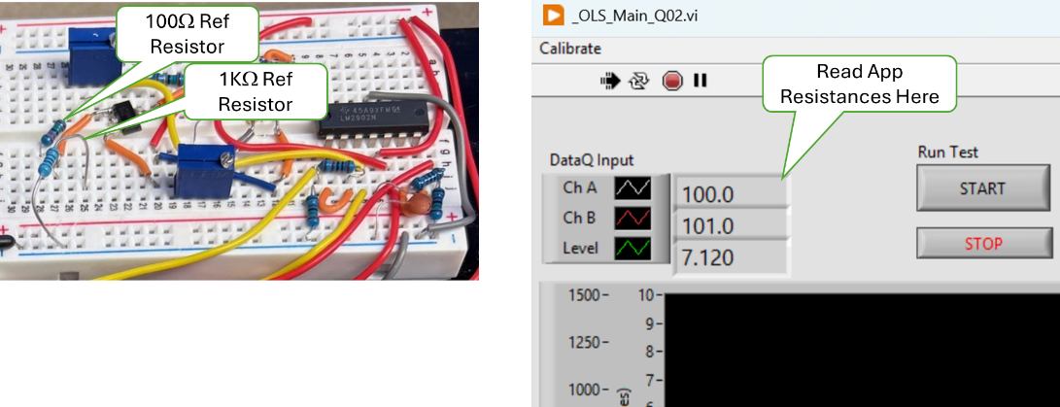

Reference Resistors and Measurement Readout.

Results

|  |  |  |  |  |  |
| --- | --- | --- | --- | --- | --- |
| **Ch** | **100Ω** | **100Ω Error** | **1kΩ** | **1kΩ Error** | **2KΩ** |
| REF |  |  |  |  |  |
| CHA |  |  |  |  |  |
| CHB |  |  |  |  |  |

* Both the 100Ω and 1KΩ Error for ChA is less than 1.0%.
* Both the 100Ω and 1KΩ Error for ChB is less than 1.0%.
* Both ChA and ChB read more 1.7KΩ or more for the 2KΩ resistor.

Tester __________________ Date ______________ PASS FAIL

1. ChA and ChB Current Source 14.7 mA +/- 0.05%

Equipment required:

Ammeter (AM);

100Ω and 1KΩ reference resistors.

1. Set the AM to the 100mA range and ensure that the probes are set to read current.
2. Connect the AM + (pos) lead to the ChA Orange lead and connect he AM – (neg) lead to the + side of the 100Ω reference resistor, ensure the other end of the reference resistor is connected to ground.
3. Record the current reading the current. ___________________ mA
4. Connect the AM + (pos) lead to the ChA Red lead and connect he AM – (neg) lead to the + side of the 1kΩ reference resistor, ensure the other end of the reference resistor is connected to ground.
5. Record the current reading the current. ___________________ mA

* The current reading (*X*) for ChA was 14.693 <= *X* <= 14.707 mA
* The current reading (*X*) for ChB was 14.693 <= *X* <= 14.707 mA

Tester __________________ Date ______________ PASS FAIL

1. Resistance measurement calibration check shall be enforced monthly.
2. In the Win11 search bar type “RegEdit” and start the Registry Editor.
3. In the folder tree in the left pane navigate to:

Computer\HKEY_CURRENT_USER\Allen AirCraft\Elevate OLS Test

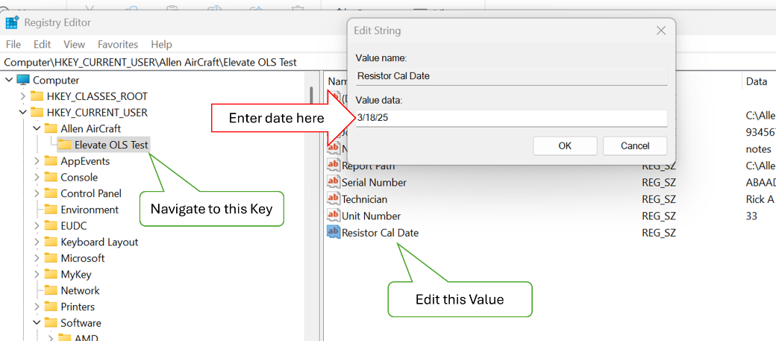

1. Open the Elevate OLS Test Key folder, then click on Resistor Cal Date, Edit.
2. In the Edit popup add today’s date + 30 days. Start the MLOI application.

* Verify there was no prompt to perform a resistor calibration.

1. Stop the MLOI application
2. Edit the Resistor Cal Date registry key to be today’s date + 31 days. Start the MLOI application

* Verify the user was prompted to perform a resistor calibration.

1. Stop the MLOI application.

Tester __________________ Date ______________ PASS FAIL

1. Level measurement (Process Variable PV) 2.5 to 8.5 inches +/- 0.0005”
2. Run the Level Accuracy and Repeatability evaluation defined in Section 5.2.1.

* Level accuracy was successfully demonstrated during the Accuracy and Repeatability evaluation of Section 5.2.1.

Tester __________________ Date ______________ PASS FAIL

1. Level measurement calibration check shall be enforced daily
2. In the Win11 search bar type “RegEdit” and start the Registry Editor.
3. In the folder tree in the left pane navigate to:

Computer\HKEY_CURRENT_USER\Allen AirCraft\Elevate OLS Test

1. Open the Elevate OLS Test Key folder, then click on Level Cal Date, Edit.
2. In the Edit popup add today’s date. Start the MLOI application.

* Verify there was no prompt to perform a Level calibration.

1. Stop the MLOI application
2. Edit the Resistor Cal Date registry key to be today’s date + 1 days. Start the MLOI application

* Verify the user was prompted to perform a resistor calibration.

1. Stop the MLOI application.

Tester __________________ Date ______________ PASS FAIL

Hardware Outputs:

1. Level control (Set Point SP) 2.5 to 8.5 inches +/- 0.002”
2. Run the Level Accuracy and Repeatability evaluation defined in Section 5.2.1.

* Level accuracy was successfully demonstrated during the Accuracy and Repeatability evaluation of Section 5.2.1.

Tester __________________ Date ______________ PASS FAIL

1. Level control shall be assessment shall be enforced annually.
2. In the Win11 search bar type “RegEdit” and start the Registry Editor.
3. In the folder tree in the left pane navigate to:

Computer\HKEY_CURRENT_USER\Allen AirCraft\Elevate OLS Test

1. Open the Elevate OLS Test Key folder, then click on Level Control Assess Date, Edit.
2. In the Edit popup add today’s date + 1 year. Start the MLOI application.

* Verify there was no prompt to perform a Level calibration.

1. Stop the MLOI application
2. Edit the Level Control Assess Date registry key to be today’s date + 1 day and + 1 year. Start the MLOI application

* Verify the user was prompted to perform a assess the Level Control.

1. Stop the MLOI application.

Tester __________________ Date ______________ PASS FAIL

HMI:

NOTE: The HMI tests are evaluations of software requirements and may be evaluated in either normal or simulated modes.

1. Shall provide a one-button means for starting the automated test.
2. Click on the MLOI Desktop icon.

* Verify the application open and running and TEST State Out is in MANUAL mode.

1. Close the information dialog. Click on the Run Test START button.

* Verify the Test protocol starts, the Run Test button is RUNNING and highlighted Green and TEST State Out is in START
* Verify after the Level (green plot) reaches EMPTY (bottom of plot), TEST State Out becomes Pre-Test Fill.
* Verify after a few seconds, the resistor ladder is being plotted.

1. Click on the Run Test button..

* Verify that Run Test button returns to gray START, the test protocol stops and the Test State Out indicates MANUAL mode.

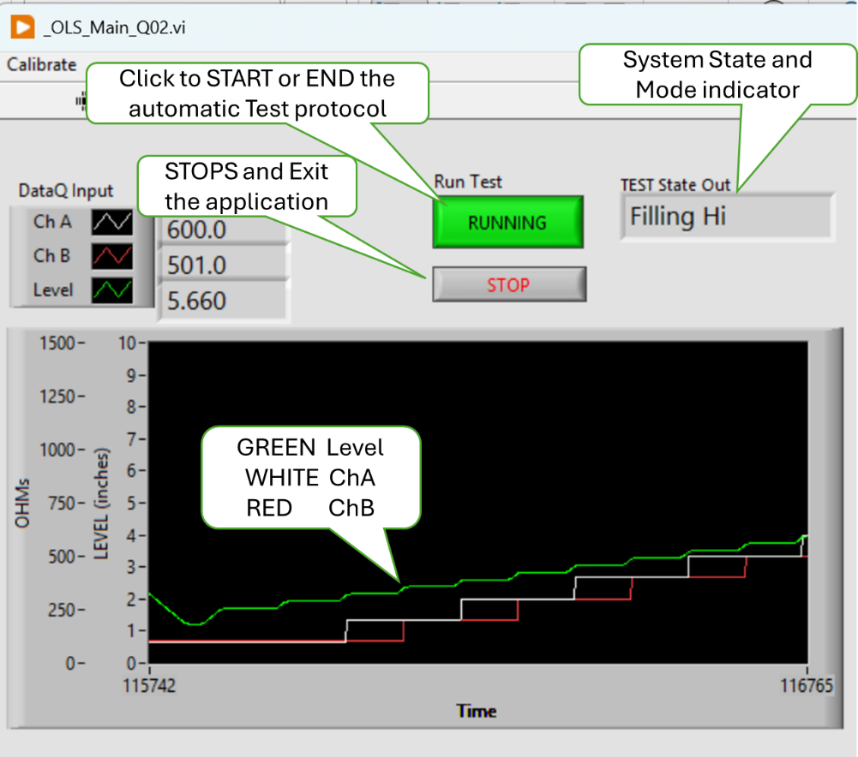

Tester __________________ Date ______________ PASS FAIL

1. Shall provide a means to manually control the Tank Level.
2. Place the Simulate button to ON (green)
3. . Sete the JOG buttons to ON (green); the FILL and DRAIN buttons to OFF (gray) and select STOP in the Speed dropdown.

* Verify that the SP Slider has no control over PV
* Verify that the SP Slider and its digital output read approximately the same value over the slider range.

1. Press the FILL Button

* Verify that the FILL button is ON (green) and the DRAIN button is OFF (gray)
* Verify that PV slider and its digital output read approximately the same value over the slider range.
* Verify the Level value (above the plot) and the PV digital output read the same Level value.
* Verify that Level and PV values decrease towards FULL and the Green plot rises.

1. Change the Pump Speed to CREEP, SLOW, FAST.

* Verify that Level, PV and the green plot respond corresponding to the selected Speed. FAST is faster than SLOW which is faster than CREEP which is faster than STOP.

1. Change the Pump Speed to Stop

* Verify the Level, PV and Plot stop changing.
* Verify that both FILL and DRAIN buttons are OFF (gray).

1. Press the DRAIN button

* Verify that the FILL button is OFF (gray) and the DRAIN button is ON (green)
* Verify that PV slider and its digital output read approximately the same value over the slider range.
* Verify the Level value (above the plot) and the PV digital output read the same Level value.
* Verify that Level and PV values increases towards EMPTY and the Green plot falls.

1. Change the Pump Speed to CREEP, SLOW, FAST.

* Verify that Level, PV and the green plot respond corresponding to the selected Speed. FAST is faster than SLOW which is faster than CREEP which is faster than STOP.
* Verify that both FILL and DRAIN buttons are OFF (gray).

1. Alternate pushing FILL and DRAIN buttons

* Verify Speed goes to SLOW.
* Verify Speed can be changed in both FILL and DRAIN modes.
* Verify FILL and DRAIN can NOT be both ON (gray) at the same time.

1. Set Pump JOG to OFF (gray). Set the SP slider to various Level Values.

* Verify the Level value, PV and Plot all drive toward the SP values and stop within 5% of the SP value.

1. Ensure that the Laser and the Pump status lights are GREEN. Then Set the Simulate button to OFF (gray).
2. Repeat Steps 2 through 8

* Verify the actual tank performed the same as the simulated tank.

Tester __________________ Date ______________ PASS FAIL

1. Shall display the current ChA and ChB measurement to 0.1Ω
2. Shall display the level measurement to 0.001”
3. Shall provide time-based plot of the resistance for both ChA and ChB, and tank Level.
4. With the MLOI app running, connect the Orange clip lead to the 100Ω test resistor and the Red clip lead to the 1KΩ test resistor.

* Verify that ChA Value and the white plot on the chart indicates about 100.0
* Verify that ChB Value and the red plot on the chart indicates about 1000.0
* Verify that the Level reading is to three (3) decimal places and is displayed as green plot on the chart.

1. Connect the Orange clip lead to the 1KΩ test resistor and the Red clip lead to the 100Ω test resistor.

* Verify that ChA Value and the white plot on the chart indicates about 1000.0
* Verify that ChB Value and the red plot on the chart indicates about 100.0
* Verify that the Level reading is to three (3) decimal places and is displayed as green plot on the chart.

Tester __________________ Date ______________ PASS FAIL

1. Shall display instrument status.

NOTE: This is a duplicate, see Test Case 4).

1. Shall display the Pass/Fail status and progress of the test.
2. With the MLOI app running, Press the Run Test button to Running (green). Let the test progress.

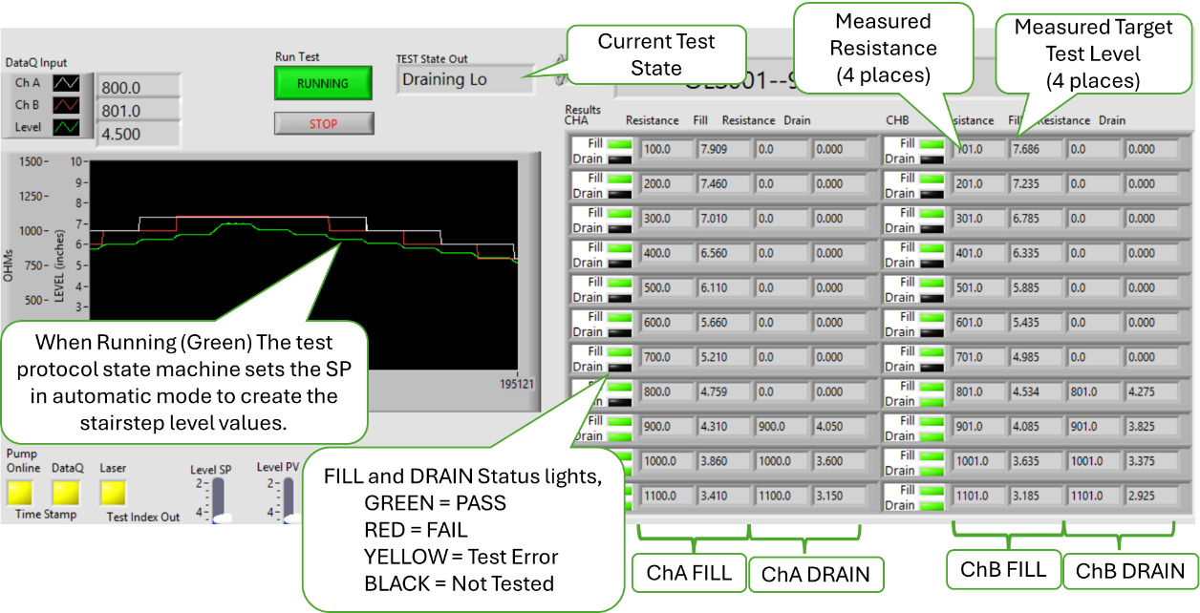

* Verify that Test State Out is sequencing through the test protocol.
* Verify the plots on the charts indicate the test protocol progress as stair step plots.
* Verify both the Fil and Drain status lights indicate test status as the test progresses.
* Verify the Resistor and Fill/Drain field are populated with the ChA, ChB and Level PV values as the test progresses.

1. When the test is completed, (DONE state) at the prompt press SAVE button then exit the test.

* Verify that a report is generated and saved as an XL workbook and the app closes.

Tester __________________ Date ______________ PASS FAIL

1. Shall provide a menu means to launch secondary methods.

NOT sure what I meant? Perhaps the Calibrate menu, or read registry action all TBD.

Tester __________________ Date ______________ PASS FAIL

1. Shall not require operator to enter redundant information.
2. With the app closed, click on the desktop icon.

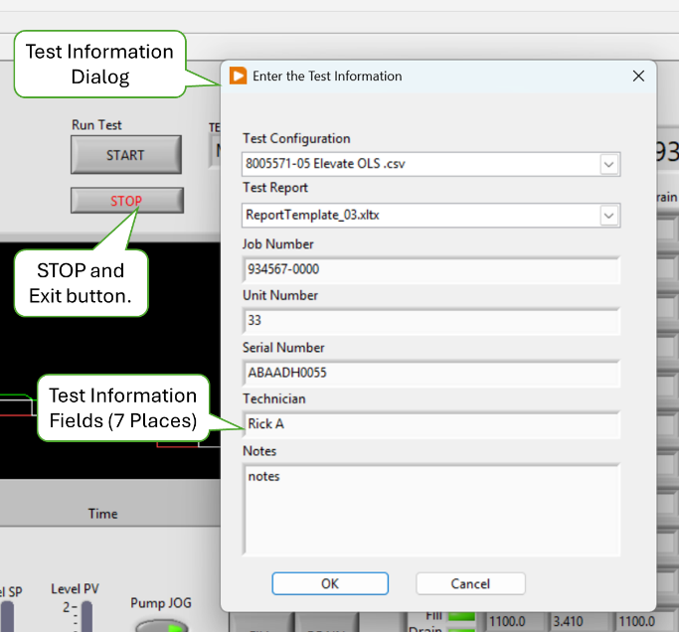

* Verify the test information dialog opens.

1. Note the values of each field, then change each test information field value.
2. Click OK to close the dialog then Click the app STOP button to exit the app.
3. With the app closed, click on the desktop icon.

* Verify that the Test information dialog opens and contains the new test information values entered in step 2.

Tester __________________ Date ______________ PASS FAIL

Document management

1. The test plan-> Configuration File shall be an XL workbook named to be traceable the test protocol implemented.
2. The test plan-> Configuration File shall be version controlled in the Test repository per AAP QUAM.
3. There shall be a means to add/include the test plan-> Configuration File path into the user prompt.
4. On the AAP network, navigate to the Configuration document in the form of an XL workbook (Config File) located in AAP Controlled Documents Vault located at M:\<Path to Controlled Documents Vault>.

* Verify that the Config File was approved by Engineering and Quality Assurance.
* Verify that the current version of the Config File is saved in the AAP Controlled Documents Vault located at M:\<Path to Controlled Documents Vault>.
* Verify the Config File name contains the common part number of the product associated with this test protocol configuration.

1. With the app closed, click on the desktop icon
2. If the Configuration File Path does not show the desired product test config file selected or not the path of the controlled document, then perform Steps 4 through 5.
3. Click on Test Configuration to open the dropdown list of files.

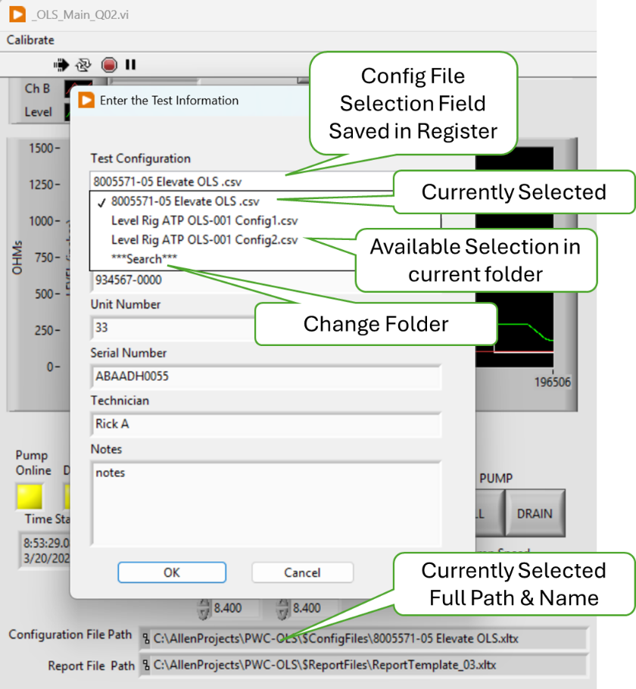

1. Click on “**Search**” in the dropdown list to navigate to a new folder and open the selected Config file. Press OK.

* Verify the select path and file are displayed in the Configuration File Path indicator.

1. Close and re-open the application

* Verify the path shown in the Configuration File Path indicator persists from one app activation to the next.

1. Using the Test Configuration drop down change Config file from the list presented. Press OK.

* Verify the select path and file are displayed in the Configuration File Path indicator.

1. Close and re-open the application

* Verify the path shown in the Configuration File Path indicator persists from one app activation to the next.

Tester __________________ Date ______________ PASS FAIL

Enter parameters into XL Configuration File.

1. The test plan-> Configuration File shall contain the configurable test bench parameters as determined by the test bench design.
2. Tabular data should be a copy and paste operation from the reference Test Document (ATP) into the XL test plan-> Configuration File document for loading as a LV parameter.
3. The test plan-> Configuration File shall contain the referenced test protocol test bench parameters as determined by the test bench design.
4. It should be a copy and paste operation to include the Test bench parameters into the XL test plan-> Configuration File document.
5. The Test Plan shall contain a template of each test report generated on a separate sheet in the test plan XL workbook.
6. The test plan-> Configuration File shall be capable of containing multiple templates to accommodate recording multiple test points or variations of test protocol.
7. Find all the above required features. <Yada Yada Yada>

* Verify all the above required features.

Tester __________________ Date ______________ PASS FAIL

Calibration Procedure

1. There shall be a means to perform a 2-point linear calibration on each AI input.
2. Run the Resistance Accuracy and Repeatability evaluation defined in Section 5.2.2.

* Resistance accuracy was successfully demonstrated during the Accuracy and Repeatability evaluation of Section 5.2.2.

Tester __________________ Date ______________ PASS FAIL

1. There shall be a means to perform a 5-point linear calibration the Level Sensor.
2. Run the Level Accuracy and Repeatability evaluation defined in Section 5.2.1.

* Level accuracy was successfully demonstrated during the Accuracy and Repeatability evaluation of Section 5.2.1.

Tester __________________ Date ______________ PASS FAIL

1. These Bench calibrations shall be saved and linked to the Test Plan.
2. On the Win11 LV workstation, navigate to C: \\<Root path of Application>\$Calibration folder. Open file “Cal Level RnR nnnn.xlsx”.

* Verify that both the level and resistance calibration raw values are recorded sequentially each time a calibration is run thus maintaining a calibration history.
* Verify the calibration parameters, slope (*m*) and offset (*b*) are calculated from the raw calibration data.

1. Navigate to the M:\<AAP controlled doc vault>\$ConfigFiles and open the current <Config File>.xlsx.

* Verify that the calibration parameters *(m* or *slope* and *b or offset*) and calibration date are stored as the default for each active channel requiring calibration.

1. Start the MLOI app. On the menu bar Select Calibration>Show all.

* Verify that the calibration parameters *(m* or *slope* and *b or offset*) and calibration date are stored in the registry each active channel requiring calibration.

Tester __________________ Date ______________ PASS FAIL

Troubleshooting Aids

1. There shall be a means for manually setting the tank level.

NOTE Manual control of the pump was demonstrated in Test Case 13).

* Test Case 13) was successfully completed.

1. If the Interface board has a Local/Remote and Fill/Drain switch, then these switches can be used to control the pump and the tank level. Set the Local/Remote switch to Remote and Fill/Drain switch to OFF.

* Verify the pump is OFF

1. Set the Local/Remote switch to Remote and Fill/Drain switch to FILL

* Verify visually the tank level is rising. .

1. Set the Local/Remote switch to Remote and Fill/Drain switch to DRAIN.

* Verify visually the tank level is Falling.

Tester __________________ Date ______________ PASS FAIL

1. Each instrument (DataQ, Keyence) shall provide a health indicator.

NOTE: This requirement was evaluated by Test Case 4).

* Verify Test Case 4) was successful.

Tester __________________ Date ______________ PASS FAIL

1. There shall be a simulated mode that provides simulated instrument input and Level response to be used with debugging.

NOTE: This requirement was evaluated by Test Case 18).

* Verify Test Case 18) was successful.

Tester __________________ Date ______________ PASS FAIL

1. TBD There shall be a test vector mode that reads and processes AEPS type test data to validate the system processing algorithm.

NOTE, In the early development stage, I wrote an algorithm to read and AEPS data as an alternative input source, is this feature something we wish to keep in the final product?

Tester __________________ Date ______________ PASS FAIL

Use Case 3: Read Test Configuration -- Production Test User

1. LV program must launch from PC desktop ICON in application running mode.

NOTE: This requirement was evaluated by Test Case 18).

* Verify Test Case 18) was successful.

Tester __________________ Date ______________ PASS FAIL

1. TBD Maintenance User exclusive controls and Indicators shall be hidden in Test mode.

The maintenance and user controls have yet to be defined. We talked about having some or all fields on the Config File password protected. There are some routines like Measure tank response, and Instrument basic connectivity that are standalone LV VI’s.

Tester __________________ Date ______________ PASS FAIL

1. All Test Parameters options must be presented in the form of a discrete choice (i.e. dropdown, pick list, radio button etc.).
2. Path to valid XL test plans shall be saved in a non-volatile means and presented as a choice by Test name configured by the Maintenance User.

NOTE: Test parameters are encoded in the Config File. The tester is presented with a dropdown to select the Config File for the product being teste. Test Information such as Lot, serial number etc.

NOTE: This requirement was evaluated by Test Case 29).

* Verify Test Case 29) was successful.

Tester __________________ Date ______________ PASS FAIL

1. The system shall be configured, initialized and shall report any NOT READY to test status: i.e. no functional instrument, out of calibration data, error reading test Plan etc.).

NOTE: Upon Test initialization, the tester is prompted to enter the Test information which includes selecting the appropriate Config File which contains all the test parameters. Test Case 20).

NOTE: The tester is prompted if a calibration activity is due. Test Cases 9) & 11).

NOTE: Instrument status is indicated on the status lights. Test Case 4)

* Verify Test Cases 4), 9), 11) and 20) are completed successfully.

Tester __________________ Date ______________ PASS FAIL

Load DUT identification information

1. Engineering shall provide an ATP Test report template that provides the reference for the required DUT Test Information.
2. Navigate to M: \\<AAP Controlled Doc Vault>\$Config File folder and open the current test Config File.
3. Note the file name save in the Report File Template parameter.
4. On the Win11 LV workstation, navigate to C: \\<Root path of Application>\$Reports folder and open the file named in step 2.

* Verify the ATP Card on sheet 1 (ATP) conforms to the ATP specified for the specific product.
* Verify the data and chart framework exists on sheet 2 (RAW DATA).
* Verify the data analysis framework exists on sheet 3 (Analysis).

Tester __________________ Date ______________ PASS FAIL

1. There shall be a single dialog box to enter the required DUT test information.

NOTE: Upon Test initialization, the tester is prompted to enter the Test information which includes selecting the appropriate Config File which contains all the test parameters. Test Case 20).

* Verify Test Case 20) was successful.

Tester __________________ Date ______________ PASS FAIL

1. The DUT information input shall be displayed and request conformation, in the form of an “are you sure?” type prompt with a YES, NO choice response. On NO reply, the user must be able to update that input which shall be retained but editable.
2. Start the MLOI app. Enter the Test Information in the dialog, press OK>

* Verify data in the Test Info table matches the information entered in the dialog box.
* Verify the test is paused and the tester is prompted “Ready to Start?’

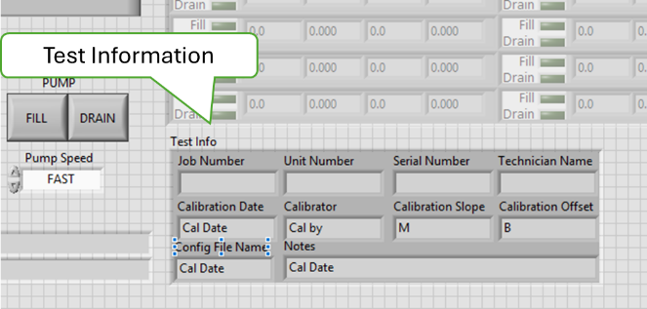

Tester __________________ Date ______________ PASS FAIL

Load DUT into the test bench.

1. On YES reply, the system shall perform a continuity check to indicate ready to test if continuity is detected otherwise indicate not ready for test.
2. The test status indicator may provide a tool tip as to the not ready issue.
3. Disconnect the connector from the sensor.
4. Run Test 44.

* Verify the test is paused and the tester is prompted “Check Connection’

1. Reconnect the connector to the Sensor

* Verify the test is paused and the tester is prompted “Ready to Start?’

Tester __________________ Date ______________ PASS FAIL

Use Case 5: Run DUT Test -- Production Test User

1. The Test protocol shall implement the ACCEPTANCE TEST PROCEDURE FOR ALLEN 8005571.05, Report# 200333. (attached)
2. Verify that a design review has been completed, and the proposed test protocol has been validated by AAP Engineering and Quality stakeholders.

* Test Protocol has been validated.

Tester __________________ Date ______________ PASS FAIL

1. The oil level shall be cycled from empty to full to empty prior to testing.
2. Open the config file ..\ PWC-OLS\$ConfigFiles\ 8005571-05 Elevate OLS .csv
3. Near the bottom of Column A, find “Skip Pre Lube”
4. Set Column B in that row to “YES”
5. Run Test 44, press START.

* Verify the Test State Output indicates “Start” and the green level line on the chart goes to EMPTY level. Then Test State Output indicates “Filling Hi”

1. Press STOP, then click No, Quit.
2. In the Config file, row “Skip Pre Lube” set Column B to “NO” and save the config file.
3. Run Test 44, press START.

* Verify the Test State Output indicates “Start” and the green level line on the chart goes to EMPTY level. Then Test State Output indicates “Pre Fill”
* When the Level reaches FULL, verify the Test State Output indicates “Pre Drain”
* When the Level reaches EMPTY, verify the Test State Output indicates “Fill Hi”

Tester __________________ Date ______________ PASS FAIL

**TEST A:** Then next 7 requirements may be validated by running either individual tests of each requirement or a single test to validate this group of requirements as follows:

1. Start the MLOI app. Enter the Test Information in the dialog, press OK.
2. Run from Step 3.a
3. Select the Simulate
   1. to ON (This is software only validation)
   2. to OFF; connect a DUT (sensor) placed in the tank (Hardware validation)
4. Press Start while the test is running make observations as indicated
5. When the test is completed, Click SAVE to save the test report in folder ..\PWC-OLS\$ReportFiles.
6. Use the test report titled containing the current time stamp as YYYYMMDDHHMM.
7. Repeat the TEST A once, using Step 3.b.
8. The oil level shall be filled from empty to the Target Test Point.
9. Using the Test report and the ATP test procedure, verify the recorded level for each target test point is within of -0/ +0.005” of the specified ATP Spec Fill Lo value. (NOTE: Empty is larger than Full according to the ATP Spec.)

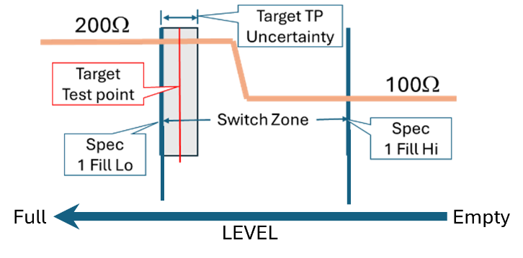

* All Fill Levels for both ChA and ChB are within spec.

Tester __________________ Date ______________ PASS FAIL

1. The Resistance shall be measured after any level variations subside to the specified criteria.
2. Verify the Filling/ Draining Test State Out is followed by a Wait_1/2 state of duration 3 seconds plus the “Wait Time” number of seconds parameter in the config file.
3. Verify that the Resistance value is not recorded until after the Wait state concludes.
4. When running on hardware, observe that the oil level is constant with no evidence of waves or the laser target float bobbing.

* Oil level and float appear stable at the time resistance is recorded.

Tester __________________ Date ______________ PASS FAIL

1. If the measured resistance is within the specified tolerance, the test at this level is PASS, else a FAIL Shall be logged.
2. As the test progresses, notice both the level and resistance are indicated on the Results Chart and indicated as follows:
   1. Dark – Not yet tested
   2. GREEN – Pass
   3. RED – Fail
   4. YELLOW – likely a measurement error.

* Pass/Fail indicator is correctly indicated on the Results Chart.

1. Compare the Report File resistances recorded on the ATP sheet to the specified values of the ATP Spec. Verify that the resistances recorded are consistent with the ATP spec.

* The recorded resistance values are evaluated in accord with the ATP Spec.

Tester __________________ Date ______________ PASS FAIL

1. The above three steps are repeated for each Low Fill Limit alternating between measuring ChA and ChB.
2. While the test is running, verify that the Status Indicators and the Level and Resistance values are alternately activated/recorded on Fill As ChA then Ch B.

* Indications occur in ChA then ChB sequence on Fill

1. While the test is running, verify that the Status Indicators and the Level and Resistance values are alternately activated/recorded on Drain As ChB then Ch A.

* Indications occur in ChA then ChB sequence on Fill

Tester __________________ Date ______________ PASS FAIL

1. The oil level shall be drained from full to the Target Test Point.
2. Using the Test report and the ATP test procedure, verify the recorded level for each target test point is within of -0/ +0.005” of the specified ATP Spec Drain Hi value. (NOTE: Empty is larger than Full according to the ATP Spec.)

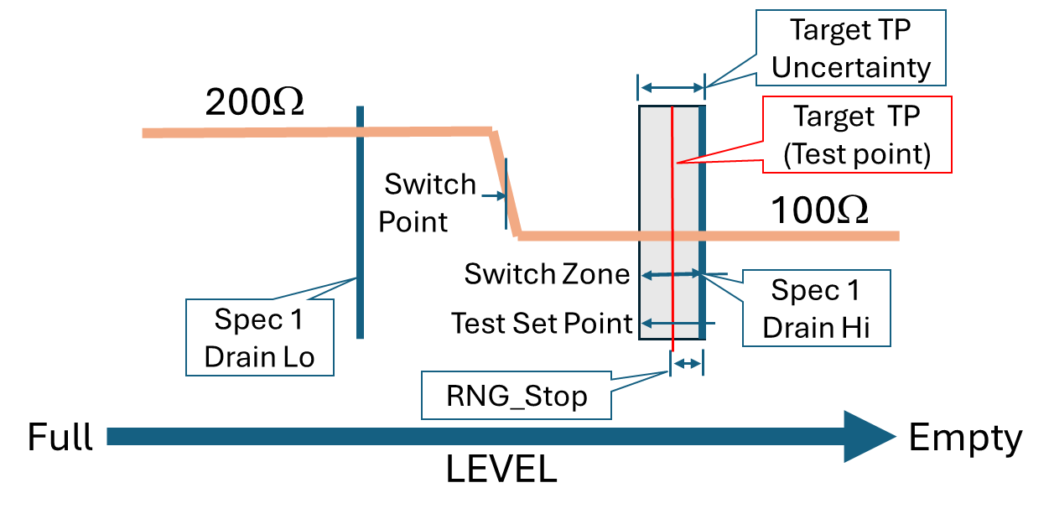

* All Drain Levels for both ChA and ChB are within spec.

Tester __________________ Date ______________ PASS FAIL

1. The Resistance shall be measured after any level variations subside to the specified criteria.

* Same as Requirement 50 but in Drain direction.

Tester __________________ Date ______________ PASS FAIL

1. If the measured resistance is within the specified tolerance, the test at this level is PASS, else a FAIL Shall be logged.

* Same as Requirement 51 but in Drain direction.

Tester __________________ Date ______________ PASS FAIL

1. The above Three steps are repeated for each High Drain Limit, alternating between measuring ChA and ChB.

* Same as Requirement 52 but in Drain direction.

Tester __________________ Date ______________ PASS FAIL

1. The DUT shall be recorded as PASS if no FAILs are recorded.

* Same as Requirement 53 but in Drain direction.

Tester __________________ Date ______________ PASS FAIL

1. The test status shall graphically display Ch A & Ch B resistance in ohms and display the Level in inches.
2. While running TEST A, verify Resistance for Ch A and Ch B are displayed on the graph.
3. Verify that level is displayed on the graph.
4. Verify the Resistance for Ch A and Ch B and the Level numeric values are displayed on the upper left-hand corner of the graph.

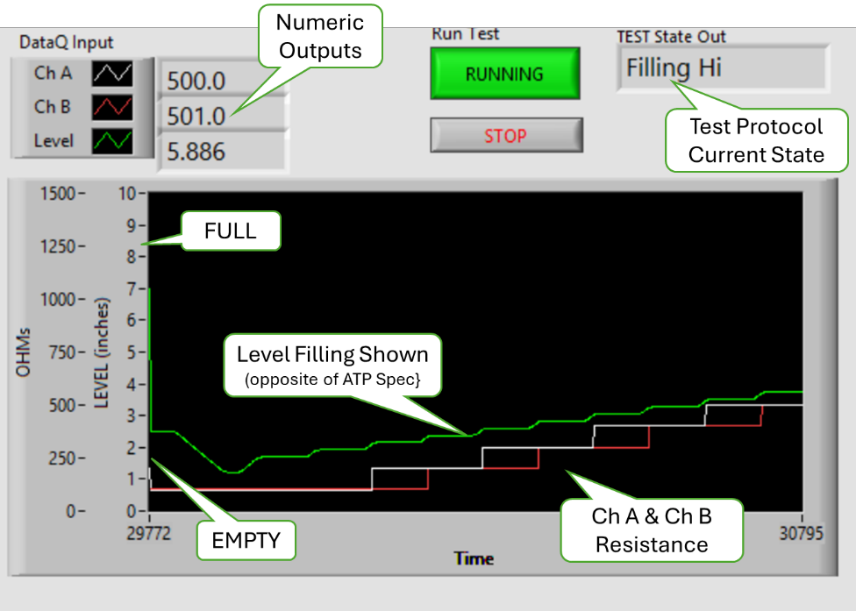

* Resistance and Level shown in real-time on the chart.

Tester __________________ Date ______________ PASS FAIL

1. All three traces shall be scaled so they are presented overlayed at a similar size. The Chart scale is a configurable test parameter.
2. TBD need to validate this requirement

Tester __________________ Date ______________ PASS FAIL

1. A display shall indicate each Switch status as NOT TESTED (gray), PASS (green) or FAIL (red) or ERROR (yellow) for a detected procedural problem.
2. Run the Test vector then verify Needs more development to test.

* The results chart displays the appropriate status indication.

Tester __________________ Date ______________ PASS FAIL

1. A display shall indicate the measured Target Test Point and the actual resistance measured there.
2. Same as Requirement 50 and 51.

* Requirement met.

Tester __________________ Date ______________ PASS FAIL

1. The User must have the means to monitor the Test bench health during testing.
2. Same as Requirement 60.

* Verify the Error Message in the Results chart status.

1. While running TEST A, disconnect the sensor,

* Verify that the continuity error is displayed.

Tester __________________ Date ______________ PASS FAIL

1. Users must have a means to PAUSE the test.
2. TBD need to validate this requirement

* All,,,

Tester __________________ Date ______________ PASS FAIL

1. Users must have a means to ABORT the test.
2. While running TEST A, press the STOP button.

* Verify the “Test Complete” dialog opens.

1. At the “Test Complete, Save Results?” prompt, Click “No Quit” button.

* Verify the program ends
* Verify the pump stops
* Verify the report is not generated.

Tester __________________ Date ______________ PASS FAIL

1. Users must have the option to RERUN the test.
2. While running TEST A, either STOP the program or let the program end and SAVE the report.

* Verify the program stops, closes and the HMI is dismissed.

1. Click on the program Desktop Icon.

* Verify the program starts.
* Verify the test information is retained from the previous run.

1. Click on the START button.

* Verify the program runs from the beginning.

Tester __________________ Date ______________ PASS FAIL

1. Users must have the option to run the level in manual or automatic modes.
2. With the system connected to hardware, Click on the program Desktop Icon.
3. Click OK to dismiss the test information dialog.
4. Set Simulate to OFF and JOG to OFF

* Verify the “Pump Online” and “Laser Online” STATU indicators are GREEN

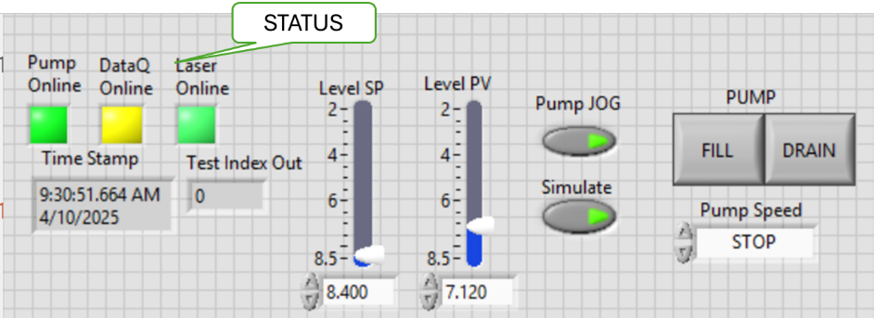

1. This is Local Automatic Control mode where the Level PV (Process Variable) should follow the Level SP (Set Point). Set Level SP to some Level.

* Verify the Test State Out is MANUAL.

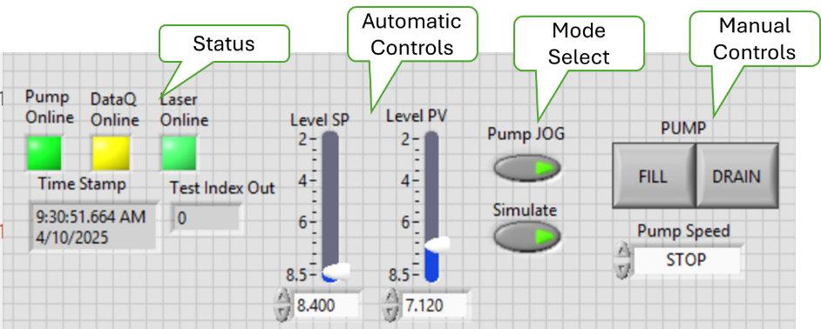

1. Repeat Step 4 for at least 4 different values.

* Verify that the pump runs until the Level PV equals the Level SP for each Level SP value.

1. Set the Pump JOG button to ON, in jog mode, the FILL and DRAIN buttons and the Pump Speed Value.
2. Press the FILL button.

* Verify the tank oil level increases at a slow rate.

1. Set the Speet to FAST

* Verify the tank oil level increases at a fast rate.

1. Set the Speed for CREEP.

* Verify the tank oil level increases at a very slow rate.

1. Press the DRAiN button

* Verify the tank oil level decreases at a slow rate.

1. Set the Speet to FAST

* Verify the tank oil level decreases at a fast rate.

1. Set the Speed for CREEP.

* Verify the tank oil level decreases at a very slow rate.

1. Set the Speed to STOP

* Verify the Pump Stops.

Tester __________________ Date ______________ PASS FAIL

1. The default test mode is Remote Automatic.
2. With the system connected to hardware, Click on the program Desktop Icon. (NOTE Simulated mode is acceptable)
3. Click OK to dismiss the test information dialog.
4. Click on the START Button.

* Verify Test State Out swithches to Start
* Verify the Level SP is set to EMPTY and the pump is running to set the Level PV towards Level SP.
* Verify once Level PV reaches EMPTY, the Remote Automatic Test Protocol runs.

Tester __________________ Date ______________ PASS FAIL

Use Case 5: Generate DUT Test Report -- Production Test User

Any of the test reports generated from previous tests of the same version of this program may be used for the following evaluations. If the report file does not exist, then run TEST A to generate a test report for this evaluation (recommended)

1. The Test results and the Product information for each test shall be saved in one XL workbook at the option of the operator.
2. The ATP Test Report shall be on one sheet labeled “ATP Report” as specified in the Report Template supplied by Engineering.
3. Navigate to folder ..\PWC-OLS\$ReportFiles and open the report file for evaluation.

* Verify a sheet named “ATP Report” exists.

1. Select sheet “ATP Report.”

* Verify the Test Product Information has been included for the following:
* Job Number
* Unit Number
* Serial Number
* Name of the Technician who ran the test.
* Date test was run
* File name of this report
* Any Notes
* Calibration info including Cal Date and the Tech who performed the calibration.

Tester __________________ Date ______________ PASS FAIL

1. The time in 50ms intervals, ChA and ChB resistance in ohms and Level in inches shall be recorded and plotted on a sheet labeled “Raw Data.”
2. Navigate to folder ..\PWC-OLS\$ReportFiles and open the report file for evaluation.

* Verify a sheet named “Raw Data” exists.

1. Select sheet “Raw Data”

* Verify that approximately 2300+ rows of ChA and ChB resistance in ohms and Level in inches data exist.
* Verify that the time logged in Column A has an interval of 50ms.

Tester __________________ Date ______________ PASS FAIL

1. The third sheet shall be labeled “Analysis” and include the actual level at which the Switch Point occurred (LSWP refer to figure 2).
2. The sheet labeled “Analysis” shall include identification of “double actuations” (definition TBD) and slow “rise time” (definition TBD).
3. TBD, yet to be implemented.

* All hardware files are in the release folder at <Path file>

Tester __________________ Date ______________ PASS FAIL

1. The values on the Analysis sheet may be calculated post-test execution.
2. TBD yet to be implemented.

* All hardware files are in the release folder at <Path file>

Tester __________________ Date ______________ PASS FAIL

* 1. Performance Requirements Test Procedures

The following test procedures are used to determine the suitability of the apparatus for Oil Level any qualification and/or production testing. All instruments used as part of the apparatus and those used as Calibration reference in these tests along with their calibration dates should be listed as part of the test report in the table below.

Table in Instruments

|  |  |  |  |  |
| --- | --- | --- | --- | --- |
| **Instrument** | **Asset ID** | **Type** | **Calibration Date** | **Note** |
| Keyence LK-G3000 |  | Laser Level Sensor |  | Apparatus |
| DataQ DI-2801 |  | Voltage Data Acquisition |  | Apparatus |
| Production Fluke |  | V, A, Ω Meter |  | Cal Reference |
|  |  |  |  |  |

Level Calibration Repeatability & Accuracy

1. Connect the hardware USB hub to the PC then load run the calibration program. (This can be call from the Main MLOI application menu or run as the standalone $OLS_LevelZeroVerification.vi)

* Verify that the Pump, and Laser Online status are GREEN. (DataQ is Don’t Care.)

1. Enter the Tester name as it will be recorded in the ATP Report.
2. The program will set 5-level set points (SP) the first at EMPTY level then three at random levels approximately every 20% +/- 0.100” of full scale and the fifth at FULL Level. When prompted enter the Raw Laser reading.

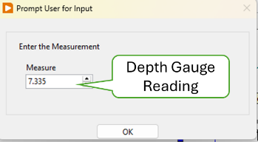

1. After the fifth run, the operator is prompted to select the csv file where the calibration is saved. Save the Slope and Offset in the Gage R&R form. (see form for instructions.)

* Verify that the calibration saved in the Cal File is the same as displayed in the Calibrate utility.

1. This test should be repeated at least 5 times by 3 different operators.
2. Record the Precision/Tolerance Ration (%Tolerance) from the Gage R&R Form.

* Verify the % Tolerance is < 10%.

Tester __________________ Date ______________ PASS FAIL

Resistance, Calibration, Repeatability & Accuracy

1. Connect the hardware USB hub to the PC then load run the calibration program. (This can be call from the Main MLOI application menu or run as the standalone $OLS_LevelZeroVerification.vi)

* Verify that the Pump, and Laser Online status are GREEN. (DataQ is Don’t Care.)

1. Enter the Tester name as it will be recorded in the ATP Report.
2. The program will set 5-level set points (SP) the first at EMPTY level then three at random levels approximately every 20% +/- 0.100” of full scale and the fifth at FULL Level. When prompted enter the Raw Laser reading.

1. After the fifth run, the operator is prompted to select the csv file where the calibration is saved. Save the Slope and Offset in the Gage R&R form. (see form for instructions.)

* Verify that the calibration saved in the Cal File is the same as displayed in the Calibrate utility.

1. This test should be repeated at least 5 times by 3 different operators.
2. Record the Precision/Tolerance Ration (%Tolerance) from the Gage R&R Form.

* Verify the % Tolerance is < 10%.

Tester __________________ Date ______________ PASS FAIL

Measurement Gage R & R

Stability and Drift

Tank Response and Fill Rate

1. Hardware Installation
   1. DataQ Switching between LibUSB and CDC Modes

The native communication mode of the DI-2108-P is LibUSB but it can be switched to the USB CDC (Communication Device Class). CDC mode allows the USB port of DI-2108-P devices to appear like a traditional RS-232 port, which is common across most operating systems and development languages.

Please note: LibUSB communication is required for WinDaq Acquisition software.

Switch to CDC mode when running the LabVIEW automation programs. Use the following sequence to switch your device to/from LibUSB/CDC modes:

* 1. Connect the device to your PC via the USB port.
  2. Apply power to the device.
  3. When mode LED stops blinking white and is in Idle mode, push and hold the Control button. This must be completed within five seconds after the device is in Idle mode.
  4. When the mode LED turns red, release the Control button.
  5. The Mode LED will flash white then indicate Idle in either LibUSB or CDC mode. CDC mode: Blinking Yellow • LibUSB mode: Blinking BLUE.
  6. DataQ Troubleshooting

If the DataQ is not responding, perform the following steps.

* 1. Check the DataQ Status LED, it should be blinking YELLOW. If it is blinking BLUE, then switch to CDC mode (see above in Appendix I.i)
  2. Cycle power to the DataQ by unplugging and replugging the DataQ USB Cable.
  3. Verify the DataQ is registed as a comport (COM 3 or *X*) in Device Manager.
  4. Reboot the computer

1. Instrument Initialization
2. LabVIEW Application Installation

The LabVIEW application is run in a LabVIEW Runtime environment that must be loaded on the target workstation. And each of the instrument driver must be loaded per Appendix II. The LabVIEW app is version controlled in GitHub Allen Aircraft account in the internet cloud and should be downloaded from there.

1. Have the IT department load the LabVIEW Runtime on the target workstation.
2. Contact AAP IT department for GitHub login credentials.
3. Open an internet browser and navigate to <https://github.com/AllenAircraft/PWC-OLS/tree/main>.
4. On the Code page, from the top left button, select the code revision to be evaluated. Note that the Main branch is always the latest release

.

1. Scroll down and open the builds folder, select folder “PWC-OLS” and copy.
2. Paste the copied PWC-OLS folder to the target system. Open the new PWC-OLS folder on the target system and click on _OLD_Main2_xxx.exe to run the program.

NOTE: It is convenient to make a shortcut to _OLD_Main2_xxx.exe and place that shortcut on the target desktop.